**Department of Electrical and Computer Engineering**

**North South University**



**CSE 299.4**

**Junior Design Project**

**MASS MESSAGING AND DATABASE INPUT**

**Group # 06**

**Shams Saniat ID # 1821848042**

**Fahad Mohammed ID # 1712483642**

**Md. Jahirul Islam ID # 1821368642**

**Faculty Advisor:**

**Zunayeed Bin Zahir**

**Lecturer**

**ECE Department**

**Summer, 2021**

**Acknowledgement**

First of all, we would like to express our profound gratitude to our honorable course instructor, **Mr. Zunayeed Bin Zahir,** for his constant and meticulous supervision, valuable suggestions, his patience and encouragement to complete the thesis work.

We would also like to thank the ECE department of North South University for providing us with the opportunity to have an industrial level design experience as part of our curriculum for the undergraduate program.

Finally, we would like to thank our families and everybody who supported us and provided with guidance for the completion of this project.

**Abstract**

In this report, we have presented a software with image recognition system that has the capability to store multiple data at a time in the database using optical character recognition and mass text messaging system. In this project, we have used image recognition module, pattern recognition, image processing, digital signal processing, artificial intelligence and a variety of other fields are all involved. Using the OCR technology, the text recognition task is divided into two steps: single character segmentation and classification. This system had collected the required data from the image and store it in the database. By using that database system has send message to the targeted audience. To achieve the goal of identification, image processing and recognition has performed on the actual image transformation and transformation. This system also could search the data and retrieve it. The key idea was to make process easier and this system had saved plenty of time. A system that allows an organization or corporation to send SMS messages to thousands of subscribers' mobile devices at once. Mass text messaging can be used by a variety of organizations to communicate with their target consumers. With the rise in popularity of smart phones with high-definition cameras, OCR has a new goal in mind: more people are using their phones to photograph the things and scenes they view and extract the text information from the photos. The characteristics of this system was very suitable for many applications.

Table of Content

Chapter 1: Project Overview 1

1.1 Introduction 2

1.2 Our proposed project 2

1.2.1 Description of the idea: 2

1.2.2 Problem Statement 3

1.3 Motivation 3

1.4 Summary 4

Chapter 2: Related work 5

2.1 Introduction 6

2.2 Content Detection of Image Processing 6

2.2.1 Content Recognition 8

2.2.2 Table Spotting 9

2.3 Bulk Message Advertising 9

2.3.1 Consumer Attraction 10

2.3.2 Informativeness 10

2.3.3 Credibility 10

2.4 Summary 11

Chapter 3: Theory 12

3.1 Introduction 13

3.2 Image Recognition 13

3.3 Optical Character Recognition 14

3.3.1 Test Detection 15

3.3.2 Test Recongnition 18

3.4 Summary 19

Chapter 4: Structure of the system 20

4.1 Introduction 21

4.2 Procedure and Functionality 21

4.2.1 Procedure 21

4.2.2 Functions 21

4.3 Workflow and Algorithms 2

4.3.1 Outline of the workflow 23

4.4 Equipment and Schematic Diagrams 24

4.5 Summary 26

Chapter 5: Twilio Messaging API  27

5.1 Introduction 28

5.2 Twilio 28

5.3 Twilio API: Access Tokens 28

5.4 Send messages with the SMS API 29

5.5 Bulk SMS Messaging Made Easy with The Cloud 30

5.6 Summary 31

Chapter 6:  OCR Technology & PyTesseract  32

6.1 Introduction 33

6.2 Experiment and setup 33

6.3 OCR Technology 34

6.4 Tesseract 35

6.5 Summary 36

Chapter 7: Results and Discussion 37

7.1 Introduction 38

7.2 The accuracy of OCR 47

7.3 The accuracy of Tesseract 48

7.4 Limitation 50

7.5 Summery 51

Chapter 8: Conclusion 54

Bibliography 37

Appendices 82

Appendix A: Text Detection 83

Appendix B: Mass Messaging89

Appendix C: Database 93

**List of Figures**

|  |  |  |
| --- | --- | --- |
| **Fig No.** | **Figure Caption** | **Page No.** |
| **3.1** | Flow chart of character image pre-processing | 14 |
| **3.2** | Faster RCNN is able to closely detect the text | 16 |
| **3.3** | The changed way of how anchor is set in Faster RCNN | 17 |
| **3.4** | The Whole CTPN | 17 |
| **3.5** | The EAST Network | 18 |
| **4.3** | Flowchart for image processing and obtaining text | 24 |
| **4.4** | Algorithm proposed for text detection and recognition | 25 |
| **6.2** | Experiment Analysis | 34 |

# Chapter 1

# Project Overview

### 1.1 Introduction

Mass text messaging is a communication service that lets an organization or business send SMS messages to thousands of subscribers’ mobile devices at the same time. Organizations of all types are using text messaging to help communicate with their target audiences. Mass texting saves considerable time and effort by allowing one consistent message to be broadcast to a large number of contacts, customers, employees, or supporters. In order to send the targeted SMS to the user, we often collect the user data. In traditional method, we take input manually from various sources and input to the database. In this software system, we will scan the image and image recognition system will take the required data of the individual user. By using image recognition system, the system will keep the information in the database. Using OCR to database, scanned images can be transferred directly to a database where they are converted into searchable documents and then stored and processed. Ultimately when software is used user do not have to spend hours locating files in the database and therefore their time and energy can be saved, leading to cost savings. Using the database, we will able to send a message to the targeted users.

## 1.2 Our proposed project

The main idea of our project was to build a mass messaging and store multiple data at a time using image recognition system.

### 1.2.1 Description of the idea:

The software was intended to provide fast, secure and improve the quality of service to store data by making the platform more efficient. It will be easy to use and it involves pattern recognition, image processing, digital signal processing, artificial intelligence and other disciplines. It has important use value and real-time monitoring system.

**Capability of the software:**

The software has the capability to --

* Sending message to the targeted audience
* Turning the elements from a image into valuable data
* From the image recognition output, the system will keep the information in the database
* By using the database, we’ll able to send a message to the targeted people

### 1.2.2 Problem Statement

The level of difficulty of this project will be very high, as the image recognition system itself is a massive project. On the other hand, the project has the mass messaging system, which also a high-level project. We are going to combine these two systems and implement a new one. As we’re planning to use OCR for the image recognition system, we need to consider the difficulty and challenge of this system. OCR technology is used to convert the text in scanned paper into ASCII symbols. Current commercial OCR systems face trouble printing against shaded or hatched texts. In addition, these documents are typically scanned in grayscale or color preserved details that might have attached to the text. It needs to be binarized. Current OCR system these scanned image needs to be binarized before actual character segmentation can be done. As the regular OCR system does the Binarization to separate text from the backgrounds by global thresholding, and global thresholding is sometimes impossible for complicated images, the issue can be solved using adaptive thresholding. On the other hand, in the mass messaging system, the problem might occur when telecom companies detect fraud or spam and try to protect it by blockage of mass messaging. This happens because of the weakness of the existing system, which gives too many privileges to the users i.e., they use any desired sender ID.

## 1.3 Motivation

Technology affects almost every aspect of 21st century life, from transport efficiency and safety, to access to food and healthcare, socialization and productivity. The power of the internet has enabled global communities to form and ideas and resources to be shared more easily. Our objective was to design, develop and build a software that would able to store data more efficiently and save plenty of time. It can be used for mass messaging to the targeted people. It will save the time, we waste on storing the data manually.

Also, In the 21st century, with the popularity of smart phones with high-definition cameras, OCR has a new pursuit in its development: more and more people pick up their mobile phones to photograph the things and scenes they see and obtain the text information in the pictures.

Development in this field can open up boundless possibilities and a new era in storing data. It can result in many new applications that can be very useful and have a great impact.

## 1.4 Summary

In this chapter, we have briefly described the basics of image recognition, existing image recognition software, and the main idea on which our project was built. We have described the capabilities of the software, what motivated us to design and build this system, and our accomplishments in here. The following chapters describe the theory and details of the components used, the mechanical description, designs, and the overall structure of the system.

# Chapter 2

# Related work

## 2.1 Introduction

The existing work related to image recognition and mass messaging we had discovered and found useful, are described in this chapter. The time has changed with the help of numerous photographic equipment and convenience of mobile phone cameras which can able to capture documents and able to convert PDF or other file extension. However, most electronic device used to scan picture to PDF which is basically an image and cannot be retrieved text from it. For example, while accessing the PDF file which have scanned from a photo, is not accessible to highlight or commenting. So that, extracting text has become a burning question. Hence, OCR (Optical Character Recognition) has come to the attention of researchers. From document recognition under simple background to handwritten recognition under natural scenes has developed in OCR technology. The text can be easily extractable from simple background image. The traditional machine learning has achieved satisfactory results of extracting from simple background. For example, widely applied SVM (Support Vector Machine) proposed by John C.Platt. Nevertheless, handwritten recognition is more strenuous than ordinary document recognition because of the variation of handwriting from the people to people. A lot of troubles have seen while constructing data set and recognition. Additionally, complex backgrounds are most challenging part. This paper additionally presents another direction to measure the viability of mass content promoting on purchaser consideration. This is on the grounds that consumer consideration is the main thrust behind all sure customer conduct activities. Without the consumer's consideration, promoting endeavors are lost through perceptual impeding and particular twisting. This methodology was educated by a few contemporary.

## 2.2 Content Detection of Image Processing

In this report a few result of ongoing research project regarding OCR. We have described the history how OCR evolved before many technologies. In OCP operation, text detection is more difficult than text recognition. Abstracting the text accurately from its background is not easy task. There are many networks which come from image classification networks under general scenes. For example: ResNet, DenseNet, VGGNet etc. and some special network models, such as FCN, STN, etc. Faster RCNN is the generally used to detect network framework. Text is relatively small target compared to general objects. So based on these detection networks it gives sometimes unsatisfactory results. Researchers need to focus on the accuracy issue to improve it. In 2015, A. Detecting Text in Natural Image with Connectionist Text Proposal Network is improved by Ren et al. on itself, which was a great improvement in the field of Object Detection, shortening the detection time of a picture by about 10 times. FastrRCNN changed the search box detection part of FastrRCNN from the original selective search to the RPN network, and integrated it into the whole Detection Network, which greatly accelerated the detection. The popularity grew faster of RCNN. Zhi Tian et al. planned to apply it to text detection. Researchers proposed a novel text detection using network CTPN Network. Based on the popular target recognition network faster RCNN, the network is improved. The researchers kept experimenting with faster RCNN and found that it’s good detection effect. Moreover, it was able to detect line by line but the accuracy was low. Then a new idea came named CTPN(Context Text Proposal Network) which main idea of them is to change the setting mode of anchor in Faster RCNN. In Faster RCNN, different anchors are set according to different width-height ratios but in CTPN, researchers innovatively fix anchors with a width of 16px, and then set 9 anchors with different heights according to a certain proportion. The idea of the EAST detection network raised by Xinyu Zhou et al. This innovation includes shorten this kind of multi-stage into two-stage: FCN and NMS (Non-Maximum Suppression) which reduces time and leads better recognition. A major feature of the EAST network is Efficient detection, which removes many redundant intermediate layers. As indicated by an investigation of the above network structure, it tends to be discovered that contrasted and CTPN, EASR is intended to be less difficult and has fewer layers. Consequently, probably the greatest benefit of the EAST organization is to empower effective and quick locations. Moreover, the EAST organization enjoys another two greatest benefits: 1) Compared with CTPN, the recognition precision of level content is better, however, there are mistakes and oversights in different ways. The EAST organization performs far superior to CTPN in recognizing a multi-point text. It shows that the identification aftereffects of EAST are better when alluding to multi-point text. 2) The EAST organization can recognize long messages and word-level messages successfully. Nonetheless, the EAST organization isn't acceptable at identifying long messages because of its straightforward organization and restricted open fields. C. Distinguishing Oriented Text in Natural Images by Linking Segments, a generally novel organization, the SegLink organization, is proposed. Additionally, contrasted and CTPN, the SegLink network tackles the issue that CTPN isn't viable in distinguishing multi-point messages. The aftereffect of the SegLink Network 1) Segments are distinguished, which can be a piece of the content line. This can likewise be a person, and so on 2) Then these Segments in a similar content line are connected, which clarifies why it is called SegLink. It represents Segment and Link. This is likewise the primary development. To effectively recognize the Segments which have a place with one content line, and connect those of a similar book line, the organization model requirements to get familiar with the accompanying two things: a) The Location of Segment b) The Link Relationship between Segments. At last a merging algorithm embraced which needs to get link the segment to get the final detection box.

### 2.2.1 Content Recognition

This paper elucidates the research about text recognition. Two main parts of interest in the text recognition are the type of text, machine-printed and handwritten OCR. Little constraints are used to solve by multi-font OCR and the difficulties for fixed. One of the interesting steps in recognition us the individual character separation. Documents produced with good quality paper give the test recognition accuracy as 99%. It is much dependent on the quality of paper ink and the age of documents for the commercially available products recognition rates. But the problem arises when the cursive and normal script are split into two types. In reality it is difficult to make differentiate between them. The mixture of two types might observed frequently. There are five phases of the problem in handwritten text recognition for the writing style basis and the complexity of the segmentation stage.

### 2.2.2 Table Spotting

This paper describes the research regarding table detection. Previously, the most effective method of identifying tables without deep learning was to highlight the frame, through series corrosion and expansion activities. There are two obvious flaws in this method: 1. It is impossible to separate the contents of a table. It is unable to accurately identify tables around different border styles or tables that do not have borders. Given the variety of styles of tables, traditional theoretical identification techniques are disabled, so the author introduced the faster RCNN mentioned in to identify tables. The main point of the paper is how to distinguish a table from other textual material, since the pictures, text and forms in a document are the same as a computer. Quick RCNN is used to identify objects because in a landscape, an object is more prominent than a document table. To quickly apply RCNN table detection, the table must be prominent. It is originally used distance conversion to process the image and then quickly sent it to RCNN for training and recognition.

## 2.3 Bulk Message Advertising

This paper describes the research regarding bulk message advertising. Bulk SMS (BSMS) advertising means to spontaneous text messages which are used from commercial or other purpose. Sometimes it violates customers if it not well managed. On the other hand, it leads to privacy issue. It is also called SPAM message because it comes from unwanted sources. Spam messages have similar features with spam emails. SMS is considered as an almost instantaneous communication medium because SMS operators make use of a “store-and-forward” packet switching which means receiver can get SMS even if their phone is switched off. According to Afzal, Paras and Gangwani (2015) bulk SMS works almost all over the world if it has Global System for Mobile (GSM) based on alphanumeric characters of up to 160 characters. It provides some value-added services i.e., stock alerts, sports updates, entertainment services, news delivery, ring tones downloading and electronic commerce authentication etc.

.

### 2.3.1 Consumer Attention

This paper describes the research about consumer attention of bulk SMS. Consumer attention is a necessary consumer behavior when it is ingredient for effective SMS advertising. According to Teixeira (2014), the market for consumer attention can be regarded as a currency as it has become so competitive. Without gaining customers attention, subscribers may miss out the offer, ignore it, skip it. On the other hand, if the consumer successful to gain customer’s attention, the business can turn into a new opportunity. Teixeira (2014) expresses attention as the allocation of mental resources, visual or cognitive, to visible or conceptual objects. Before advertising consumers should pay attention first. Because without paying attention, all advertising efforts can be lost. If the advertisers pay much attention to the market research, the consumer can attract. The advertisement should be given frequently so that consumer memories it for further use.

### 2.3.2 Informativeness

In this report we discussed about informativeness. Informativeness of SMS mean the ability to get attention to the consumer giving related information in a manner that is understood by subscriber. Informative SMS shows the positive relationship between informativeness of the bulk SMS and several consumer-related variables. In line with Drossos et al. (2014), SMS advertising should be informative for it to gain subscribers attention. An obscure message could easily be changed in the customer’s mind how contributing to spamming. Other communicative bulk SMS advertisements combine SMS promotions with clear prizes and information on how to participate. If consumers notice that the text message is informative and helpful, they are more feasible to pay attention

### 2.3.3 Credibility

In this paper talks about credibility of bulk SMS. There are many SMS comes to the user but not all are the relevant and necessary. Consumers don’t accept bulk SMS advertisements that come from sources that are not credible. Strom, Vendel, and Bredican (2014) highlight that the problem of credibility in SMS advertising can be avoided in two basic ways. The first one is through building a strong brand that attracts loyalty of the customers. Once subscribers are more loyal to the brand that will heighten the credibility levels of the brand, because credibility is closely tied to trust. The more customers trust the advertising brand, the more they perceive it as credible. The second attribute that SMS advertisers should be mindful of when advertising using bulk SMSs is to brand their SMSs (Strom et al., 2014).

## 2.4 Summary

The existing work related to image recognition on text and mass messaging that we found useful have been briefly described in this section. The next chapter elaborates more on the theoretical part of our project.

# Chapter 3

# Theory

## 3.1 Introduction

The details of the theory of our system are discussed in this chapter. The theoretical explanation is divided into two sections

1. Image recognition
2. Optical Character Recognition

## 3.2 Image Recognition

The image recognition technology is closely related to social life, image recognition technology is an important branch of computer vision, neural network image recognition technology is along with the modern computer technology, image processing, artificial intelligence, and pattern recognition theory developed a new kind of image recognition technology [1]. To realize the recognition of images, the first to get corresponding image by image acquisition device, so that the digital image; Then the image recognition, and its various information. In this paper, neural network is used to analyze the acquired digital image recognition, the BP neural network is introduced into image recognition field, and combined with conventional digital image processing technology, find out a kind of strong accuracy plane image recognition method [2].

Image recognition involves a lot of information operation, requiring high processing speed and recognition precision, real-time and fault-tolerance of the neural network in accordance with the requirements of image recognition. At first, this paper analyzes the traditional image recognition method, aiming at the limitations of traditional methods, and the complex situations such as images show different state, in the process of image processing algorithm for the image segmentation study and its improvement.

Intelligent image recognition process analysis:

Image recognition as a branch of image technology has been a hot research topic in the field of image processing and pattern recognition. Traditional pattern recognition methods applied to the color of the image recognition is mainly based on image features, shape and texture characteristics of image comparison, according to the similarity between the statistical characteristics of image evaluation [3]. Neural network image recognition technology is the modern computer technology, image processing, artificial intelligence, pattern recognition theory, developed a kind of new image recognition technology, is in the traditional image recognition method based on fusion of neural network algorithm is a method of image recognition. In text image processing as an example, the character image preprocessing is designed to make character images more clear, the edge is more obvious, and every character segmentation for feature extraction. For this article selects the character images, image preprocessing, the general flow chart is shown in figure 2.

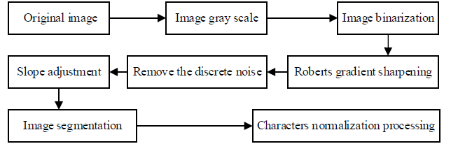

Fig 3.1 Flow chart of character image pre-processing

## 3.3 Optical Character Recognition

With the emergence of various photographic equipment and the enhanced convenience of mobile phone cameras, documents have gradually changed from previous paper materials to a wide variety of electronic ones, such as PDF file, ect. Electronic documents have attracted extensive attention and have been widely used due to its convenience and digital features. However, at present, most electronic documents, like PDF files, are scanned electronic documents, which are composed of pictures and cannot be changed additionally. For example, when using scanned PDF files, users cannot directly highlight or give comments on the documents. Therefore, how to extract text from pictures has become a hot topic. Thus, OCR (Optical Character Recognition) has come into the sight of researchers.

The research scope of OCR technology has expanded from document recognition under simple background to handwriting recognition under natural scenes as the technology processes. The simple backgrounds and the uniform printed characters make it easy to extract text from paper images. The traditional machine learning have achieved satisfactory results. For example, the SVM (Support Vector Machine) proposed by John C.Platt in [4] has been widely applied. However, handwriting recognition is more difficult than ordinary document recognition, because every handwriting word is written differently from people to people. It adds a lot of troubles to the construction of data set and recognition. The complex backgrounds are the most difficult part. Compared to the single background of documents, the background of natural scenes are complicated. They consist cars, pedestrians, etc. It is challenging to recognize text from these complex backgrounds.

Therefore, at present, OCR mainly focuses on the following three facets:

1)Recognition and transformation of traditional documents

2)Recognition of handwriting

3)OCR under natural scenes

### 3.3.1 Text Detection

Throughout the OCP operation, text detection is more difficult than text recognition. How to accurately abstract the text from its background is not an easy task. Many networks of text detection come from image classification networks under general scenes, such as VGGNet, ResNet, DenseNet, and some special network models, such as FCN(Fully Convolutional Network), STN(Spatial Transformer Network), etc. Faster RCNN is the most frequently used detection network framework. However, compared with objects, text is a relatively small target. Text is not as prominent against its background as are general objects, so copying those detection networks directly often leads to unsatisfactory results. Therefore, based on those detection networks, researchers need to do more work to improve the general detection networks to improve the detection accuracy.

A.Detecting Text in Natural Image with Connectionist TextProposal Network

In 2015, FastrRCNN, which was improved by Ren et al. on itself, was a great improvement in the field of Object Detection, shortening the detection time of a picture by about 10 times. FastrRCNN changed the search box detection part of FastrRCNN from the original selective search to the RPN network, and integrated it into the whole Detection Network, which greatly accelerated the detection. Because of the popularity of Faster RCNN, Zhi Tian et al. also planned to apply it to text detection accordingly. In [6], researchers proposed a novel text detection network CTPN Network. The network is improved based on the popular target recognition network Faster RCNN.

The researchers took text detection experiments with Faster RCNN, as shown in Figure 1 (a). They found that Faster RCNN has a good detection effect. It was able to detect every line, but the accuracy on columns is not high. Therefore, in CTPN(Context Text Proposal Network), the main idea of them is to change the setting mode of anchor in Faster RCNN. In Faster RCNN, anchors are set as shown in Figure 2, and different anchors are set according to different width-height ratios. In CTPN, researchers innovatively fix anchors with a width of 16px, and then set 9 anchors with different heights according to a certain proportion. The effect is obvious, as shown in Figure 1 (b) based on Faster RCNN. The detection of rows is effective, and the detection effect of columns is fine and accurate.

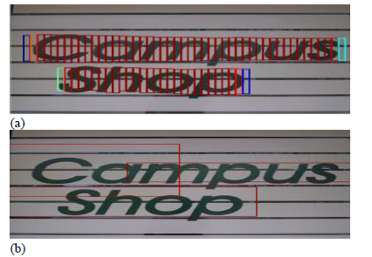

Fig 3.2 Faster RCNN is able to closely detect the text



Fig 3.3 The changed way of how anchor is set in Faster RCNN

Besides the innovation of anchor setting, as shown in Figure 3, the CTPN Network also introduced BLSTM. BLSTM is bidirectional, which is an upgrade version of RNN network. As it known to all, the biggest feature of RNN series networks is that they integrate contextual information for training. In traditional neural networks, the information of each iteration training will not be related except the gradient. However, one input of RNN series network is the information of last training, so RNN series network is context-related network. In CTPN, the anchors of text are also context-related, and it is meaningless to take out a single anchor independently. Therefore, it is obvious an improvement of anchor recognition’s accuracy by introducing BLSTM.

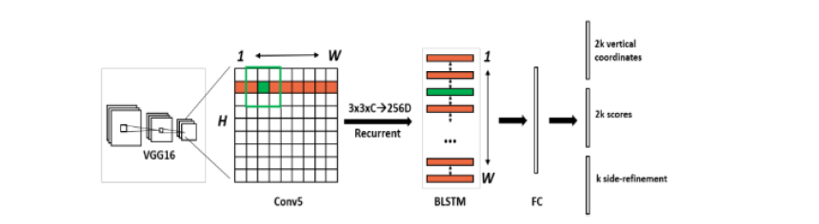

Fig 3.4 The Whole CTPN

*B. EAST: An Efficient and Accurate Scene Text Detector*

Traditional text detection methods, as well as some text detection methods based on Deep Learning, are mostly multi-stage. Therefore, we should adjust parameters of each stage separately during training, which not only consumes time, but also accumulates errors of each stage layer by layer, and then the final detection results are not ideal.

In [7], Xinyu Zhou et al. have raised the idea of the EAST detection network. One of its key innovations is to shorten this kind of multi-stage into two-stage: FCN and NMS (Non-Maximum Suppression), which not only reduces the detection time, but also leads to better recognition. Efficient detection is a major feature of the EAST network, which removes many redundant intermediate layers. The network structure is shown in Figure 4, which is divided into three parts.

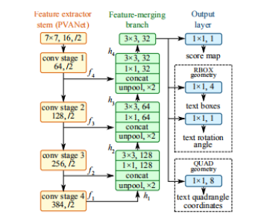

Fig 3.5 The EAST Network

Up to now, CTPN is the most developed Text Detection Network, which takes the lead of recognition accuracy. However, it does not mean that it is a perfect network. The training and recognition speed of CTPN is not satisfactory, and many researchers are committed to optimizing CTPN at present.

### 3.3.2 Text Recognition

Using the previous OCR technology, the text recognition task is divided into two steps: single character segmentation and classification. The traditional way is to cut out a single character by projection, then classify and recognize this single character. It can be found that the robustness of this method is not good, because when characters are cut by projection, it will be affected by intermediate step errors, such as binarization, Gaussian Blu, etc. These errors will gradually accumulate, resulting in an unsatisfactory segmentation, and a worse result of classification and recognition. At present, deep learning is widely used in various fields, so the traditional text recognition method is outdated. It is more popular to add deep learning method in the present day. This series of methods does not need to divide the text explicitly, but to recognize the whole text image.

After converting texts into sequences, an end-to-end text recognition net can be realized by different network and translation, which is better than traditional methods in recognition accuracy and robustness.

At present, there are two trends in end-to-end text recognition tasks: CRNN (Convolutional Recurrent Neural Network) and Attention. The difference between these two methods lies in the output layer. The two main methods both apply the network structure of CNN+RNN, and the difference is how to transform the sequence feature learned by the network into recognition results. The method that CRNN adopts is the CTC (Connectionist Temporal Classification) Algorithm, while the Attention type adopts the Attention Mechanism.

## 3.4 Summary

In this chapter, the theoretical part of our project has been described. We have tried to explain how image recognition works in detail, and the theory of how we can detect the text from image by using optical character recognition system. All necessary equations and figures have been shown.

# Chapter 4

# Structure of the system

## 4.1 Introduction

The structure of how the system works is discussed in this chapter. We have designed a software to provide fast, secure and improve the quality of service to store data by making the platform more efficient. It has important use value and real-time monitoring system. In our project we have used Image recognition module in order to capture image to store the data in it. We also designed mass messaging system to send messages to the user that store in the database.

## 4.2 Procedure and Functionality

Before describing the workflow and algorithms of the system, how the system works has been explained first.

### 4.2.1 Procedure

To send bulk SMS from this system first select the registered Header. Then enter the mobile number of the message recipients and select the registered message template. Lastly click on send after providing all the details. User have to upload the picture in the system and system will process the picture using tesseract method. After the processing system gives the output as a text.

### 4.2.2 Functions

Image processing is a software focused domain. OCR Software like Tesseract can be used to convert the image to text form. But this software is prone to errors, especially if the quality of the image is not pristine. The image needs to be processed using OpenCV and the processed image can be fed to Tesseract to get much better results.

A. Python : Python is a widely used high-level, general-purpose, interpreted, dynamic programming language. Its design philosophy emphasizes code readability, and its syntax allows programmers to express concepts in fewer lines of code than would be possible in languages such as C++ or Java. The language provides constructs intended to enable clear programs on both a small and large scale. Python supports multiple programming paradigms, including object-oriented, imperative and functional programming or procedural styles. It features a dynamic type system and automatic memory management and has a large and comprehensive standard library. [16] Python programming language made us enable to write short code snippets for each processing techniques. It also enabled us to develop a multi-level processing mechanism. Thus python programming language was indeed very helpful in the digital processing of the stock images by writing simple and easily understandable python codes.

B. Tesseract : Tesseract package contains an OCR engine - libtesseract and a command line program - tesseract. The lead developer is Ray Smith. Tesseract has unicode (UTF-8) support, and can recognize more than 100 languages "out of the box". It can be trained to recognize other languages. Tesseract supports various output formats: plain-text, hocr(html), pdf. [17] The Tesseract engine was originally developed as proprietary software at Hewlett Packard labs in Bristol, England and Greeley, Colorado between 1985 and 1994, with some more changes made in 1996 to port to Windows, and some migration from C to C++ in 1998. A lot of the code was written in C, and then some more was written in C++. Since then all the code has been converted to at least compile with a C++ compiler. [18] Tesseract is available for Linux, Windows and Mac OS X, however, due to limited resources only Windows and Ubuntu are rigorously tested by developers. Tesseract up to and including version 2 could only accept TIFF images of simple one column text as inputs. These early versions did not include layout analysis and so inputting multi-columned text, images, or equations produced a garbled output. Since version 3.00 Tesseract has supported output text formatting, hOCR positional information and page layout analysis. Tesseract can detect whether text is monospaced or proportional. The initial versions of Tesseract could only recognize English language text. V3.04, released in July 2015, added an additional 39 language/script combinations, bringing the total count of support languages to over 100. Tesseract can be trained to work in other languages too. Tesseract is suitable for use as a backend, and can be used for more complicated OCR tasks including layout analysis by using a frontend such as OCRopus. In this project, Tesseract is used as the final step for OCR after the image has been sufficiently processed so as to get optimum output.

C. Twilio : Twilio's Programmable SMS API allows you to integrate powerful messaging capabilities into your apps. Send and receive SMS messages, track the delivery of sent messages, and obtain and edit message history using this REST API.

D. OpenCV : OpenCV (Open Source Computer vision) is free for both academic and commercial use. It is a library of programming functions mainly aimed at real-time computer vision. [13] OpenCV's application has wide areas which includes 2D and 3D feature toolkits, Egomotion estimation, Facial recognition system, Gesture recognition, Motion understanding, Object identification Segmentation and recognition and Motion tracking. [14] OpenCV is written in C++ and its primary interface is in C++, but it still retains a less comprehensive though extensive older C interface. [15] OpenCV contains libraries of pre-defined functions helpful in image processing. Since it is open source, it was chosen as the platform to test the project. Using OpenCV libraries we have implemented image processing mechanisms like RGB to grayscale conversion, erosion, dilation.

## 4.3 Workflow and Algorithms

This section will describe the sequence of events that result in a command being processed and a corresponding function being executed by the system.

### 4.3.1 Outline of the workflow

A few images were taken for processing. The images were in different states in terms of quality. Processing of these images by a single common code would not yield equal results. Therefore, a common code with various stages of processing was decided upon, with output of each stage fed to the Tesseract OCR. The best output from the OCR would be taken as the converted text value. Figure 4.3 Flowchart for image processing and obtaining text Figure 4.3 shows the algorithm for digital image processing and text extraction from the image.

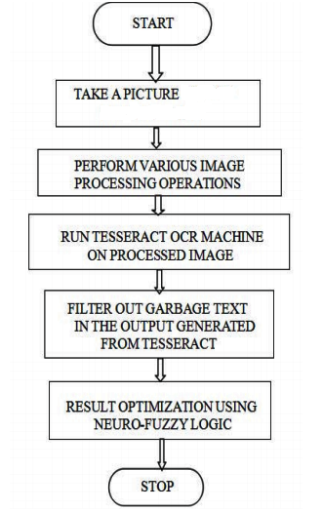

Figure 4.3: Flowchart for image processing and obtaining text

The input image taken from the stock camera of cell phone. Image was taken in daylight environment with decent ambient conditions. Running of Tesseract over this image yielded blank output. In this image, portion of license plate is clearly visible. Text result obtained after running Tesseract over this image was 'Shams'.

## 4.4 Equipment and Schematic Diagrams

The following software and API were used in this project.

* Python
* Twilio
* Tesseract

As mentioned in the introduction, the previous developments of text detection and recognition system can be classified into three typical categories:

1. Bottom-up methods: they segment images into regions and group “character” regions into words. The methods, to some degree, can avoid performing text detection. Due to the difficulty of developing an efficient segmentation algorithm for text in complex background, the methods are not robust for detecting text in many camera based images and videos.

2. Heuristic top-down methods: they first detect text regions in images using heuristic filters and then perform bottom-up techniques inside the text regions. These methods are able to process more complex images than bottom-up approaches. However, the manually designed filters are empirical and therefore produce many false text regions, which are referred to as false alarms.

3. Training-based top-down methods: the text detection step is based on filters that are trained using machine learning tools. The method we propose belongs to the top-down category, and consists of two main tasks as illustrated by Figure 4.4 : a text detection task and a text recognition task applied to the detected

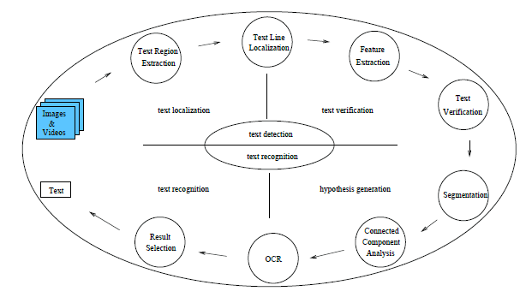

Figure 4.4: Algorithm proposed for text detection and recognition.

text regions. Following the cascade filtering idea, which consists of the sequential processing of data with more and more selective filters, the text detection task is decomposed into two subtasks. These are a text localization step, whose goal is to quickly extract potential text blocks in images with a very low missing rate and a reasonable false alarm rate, and a text verification step based on a powerful machine learning tool. Such an approach allows to obtain high performance with a lower computational cost in comparison to other methods. To address the recognition task, we propose a multi-hypotheses approach. More precisely, the text image is segmented two or three times, assuming a different number of classes in the image each time. The different regions, all considered as text candidates, are processed by a commercial optical character recognition (OCR) engine and the final result is selected from the generated text string hypotheses using a confidence level evaluation based on language modeling. Additionally, we propose a segmentation method based on Markov Random Field to extract more accurately text characters. This methodology allowed to handle background grayscale multi-modality and unknown text grayscale values, problems that are very often not taken into account in the existing literature. When applied to real video text, it reduces by more than 50% the word recognition error rate with respect to a standard Otsu thresholding followed by the OCR [11, 12].

## 4.5 Summary

In this chapter, we have described how the system works. The sequence of events resulting in a text detection and bulk messaging command being processed, sent to the database, and then being executed has been described in detail in this chapter. We have also given diagrams of the workflow and the algorithm of command execution and the equipment used. Detailed description of the equipment used will be given in following chapters.

# Chapter 5

# Twilio Messaging API

## 5.1 Introduction

This chapter discusses the twilio Messaging API, which has been used in our project to send messages to our users. Twilio Messaging is an API to send and receive SMS, MMS, OTT messages globally. It uses intelligent sending features to ensure messages reliably reach end users wherever they are.

## 5.2 Twilio

Twilio is a developer platform for communications: the Twilio Customer Engagement Platform. Twilio’s programmable application program interfaces (APIs) are a set of building blocks developers can use to build the exact customer experiences they want.

The Twilio Customer Engagement Platform can be used to build practically any digital experience, using capabilities like SMS, WhatsApp, Voice, Video, email, and even IoT, across the customer journey. Twilio powers communications for more than 190,000 businesses, and enables nearly 932 billion human interactions every year.

## 5.3 Twilio API: Access Tokens

Access Tokens are short-lived tokens that we can use to authenticate Twilio Client SDKs like Voice, Conversations, Sync and Video. We create them on our server to verify a client’s identity and grant access to client API features. All tokens have a limited lifetime, configurable up to 24 hours. However, a best practice is to generate Access Tokens for the shortest amount of time feasible for our application.

How to create Access Tokens

Twilio Access Tokens are based on the JSON Web Token standard. You can read about the details of the JWT format for Access Tokens here, but if you’re using one of Twilio’s official helper libraries, you can use our token-generation functionality without having to know how they’re constructed.

Step 1: Create an API Key

First, you need to create an API key. This contains a secret which will be used to sign Access Tokens. You can create API keys from the Twilio Console or using the REST API. When you create the API key, you’ll be shown the key’s secret. For security, you will only be shown the secret at this time, so you should store it with the key’s SID in a secure location for the next step.

Step 2: Generate an Access Token

Now use your new API key’s secret to generate an Access Token using a Twilio Helper Library. Each token is granted access to specific client features. Below is an example which demonstrates how to generate tokens that grant access to Conversations, Voice, Video and Sync. When creating an Access Token, you must provide your Twilio Account SID, API key, and API secret.

Step 3: Authenticate

Now you’re ready to use your token. For client-side SDKs like Conversations and video, you will need to get the stringified token to your client-side code via Ajax or some other means. Refer to the Identity and Access Tokens guides in the product documentation for video or Conversations for more details.

## 5.4 Send messages with the SMS API

Twilio’s SMS API helps you send and manage messages programmatically:

To send an outbound SMS, WhatsApp, or Channels message with the API, POST to the Message resource. You’ll also use the Message resource to fetch messages and list messages associated with your account. You can also leverage the REST API to query metadata and manage your messages:

* Delete or redact content from an existing message.
* Track message feedback.
* Fetch, update, or delete media associated with a message.
* Fetch and update the short codes tied to your account.
* Manage your account’s messaging services.

## 5.5 Bulk SMS Messaging Made Easy with The Cloud

There’s much to consider when integrating a mass notification solution within your customer management software. Augmenting your communications program and platform with mass texting, whether as a customer service enhancement or a marketing tool, requires specialized software. To ensure the best customer experience possible, explore the use of cloud communication APIs to deploy your SMS Messaging solution. Here are four reasons to consider Bulk SMS Messaging activities with a trusted cloud-based service:

**1. Extensive Global Reach:** A reliable global carrier network is one of the most compelling reasons businesses turn to a cloud provider. Why? Because reputable cloud providers have established relationships with worldwide telecom providers, and have the experience of delivering billions of messages globally, giving them the ability to adjust routes in real-time to avoid delays and delivery issues. Be sure that your provider offers multiple routes to the major carrier networks, and has redundant carrier interconnects for each mobile subscriber. This will help ensure your messages get delivered in the timeframes and time zones you require.

**2. Flexible Pricing Model:** Before beginning any type of capacity planning or estimation of customer reach, look for a cloud provider that offers a pricing model that can scale as your business needs grow. There are cloud providers that offer simple usage-based models so you that only pay for what you send. In addition to program scalability and pay-as-you-go plans, look for the flexibility to secure volume discounts as you expand your reach and use of the service. If your campaigns could conceivably fluctuate from 1,000 to a million sends, be sure you only pay for the volume you use. Don’t contract for any more than that amount.

**3. Robust Software Features:** Another great benefit of working with a cloud provider is that they typically provide other communication solutions beyond Bulk SMS Messaging. Instead of sending a word-based text, innovative businesses are sending Multimedia Message Services (MMS) as well. MMS allows you to be a bit more inventive with your mass communications by sending emojis, calendar invites, polls, surveys, and picture messages. Marketers, in particular, are embracing new cloud communication platforms to also seamlessly integrate additional communication apps such as Voice, Chat, Facebook Messenger, and others.

**4. Integration Simplicity:** Your chosen cloud solution should make it easy to integrate your SMS communication application within your overall communication platform or CRM. By using cloud computing, your developers can leverage pre-built code that’s user-friendly and user-ready, to meet your Bulk SMS Messaging requirements. Look for a global SMS platform with programmable APIs that can be customized to meet your unique needs. If writing code is not part of your organization’s expertise, some providers offer drag and drop features so you can quickly and confidently create a smart SMS communication workflow. With these additional tools, your business can focus on designing the right customer communication experience rather than developing the nuts and bolts of a communication application from scratch.

## 5.6 Summary

The twilio messaging API and its features have been described in this chapter. We have also described how it works and how to access twilio tokens. Using this REST API, we can send and receive SMS messages, track the delivery of sent messages, and retrieve and modify message history.

# Chapter 6

# OCR Technology & PyTesseract

## 6.1 Introduction

Following and controlling transports is very important nowadays because of the rapid growth of transports day by day. In Bangladesh alone, Bangladesh Motor Vehicles Sales grew 5.4 % in Dec 2019, compared with a growth of 5.7 % in the previous year. Bangladesh Motor Vehicles Sales Growth rate is updated yearly, available from Dec 2006 to Dec 2019, with an average growth rate of 5.6 % With the increased number of vehicles, tracking and managing these vehicles will become more difficult. In this part, the License Plate Recognition System (LPRS) is introduced. This system or application detects a vehicle or its owner by recognizing its license plate number. This system is developed in Python programming language. To employ image processing, external libraries OpenCV and Tesseract are used in Python for optical character recognition (OCR) to extract characters from the image. LPRS is a low-cost versatile system that requires a digital camera and it is easy to perform. The license plate recognition system works in a real-time environment as it can recognize a vehicle’s license plate number even in low light environments and different states of vehicles. The license plate recognition system can even recognize different types of license plates like white number plates, yellow number plates, high-security plates, etc. The versatility of this system has been experimented with, and it gives promising and effective results. The data obtained by this system can be used in many areas like toll squares where transport and its owner information can be used to make toll payments faster, in the traffic department where it can help traffic police to find traffic rules breakers, to limit the speed of vehicles on roads appearing in improved road safety and to track irregular vehicles that will enhance the security of people.

## 6.2 Experiment and setup

In detection and recognition of something in the computer vision field, accuracy is one of the most significant features. Experiments are conveyed to test the versatility and precision of the system. The system is tested with more than 1000 images with different light conditions and positions to check if it still can recognize the license plate number with expected precision. Initially, the accuracy rate was low. The system detected all rectangular shapes in the image other than the license plate. In order to gain accuracy, the system was trained to detect shapes similar to a license plate, not all the rectangular shapes. The last stage of experiments was vital as the system was to be performed in real-time environments. The experiments were conducted in different situations which include sharp daylight, dark nights, rainy days. The experiments were also handled at traffic places and zebra crossings with different kinds of number plates. The precision acquired through experiments under various conditions is shown in Fiqure 6.2.

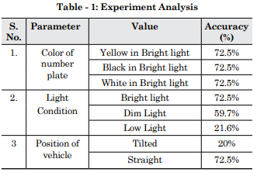

Figure 6.2: Experiment Analysis

## 

## 6.3 OCR Technology

OCR, the abbreviation of "Optical Character Recognition" refers to the idea of recognition, analysis, and perception of characters through an optical tool. In the human being, this concept is represented by the ability to read, the eyes being the optical mechanism, and the brain, namely the Wernicke area [19], the analysis and judgment of the input given. In the field of technology, OCR is the electronic or mechanical conversion of text, be it manuscript or typography, in machine language. The first concept of OCR was patented in 1929 by Tausheck in Germany, while in 1933, Handel did the same in the United States of America. These are the first known OCR records. However, it was only in the 1950s, with the arrival of computers, that this technology went from theory to follow. The operations of OCR technology can be understood in five phases. These phases are Scanning, Segmentation, Preprocessing, Character Extraction, and Recognition. In the first step, a digital image of the original document is achieved through a camera or scanner. These devices convert the received light intensity to gray levels. Normally, since most of the documents that are to be scanned are made of information represented by black color on a white background. This change is achieved through the thresholding method where pixels with gray levels that are below a certain number are converted to white and those above that number are converted to black. In the second step, segmentation, the difference between written text and images is made. It is also at this stage that all text is segmented into the most basic parts, isolating each word and each character. The scanned image may contain some noise which may resolve errors in the character recognition step. In the third step, we plan to eradicate this problem through a preprocessing of the image. The resolution of this problem involves the smoothing and normalization of characters, where "holes" in the characters are corrected through fill techniques, and the size, angle, and rotation of the characters are correct. In the fourth stage, thought the most difficult, a search is made regarding the characteristics that allow the identification of a symbol, ignoring the rest. In the last phase, the raised characteristics are compared to a set of known characteristics to be able to identify the corresponding character, thus ending the image to text conversion. [20, 21, 22]

## 6.4 Tesseract

Tesseract is an open-source OCR software generated by Hewlett Packard between 1984 and 1994. In 1995 it was featured in the UNLV Annual Test of OCR Accuracy where it obtained excellent results when compared to other available software. Its development began as a Ph.D. project and developed as a feasible add-on to the HP product line, namely the scanners. Motivated by the fact that OCR technologies are still underdeveloped and after a collaboration with HP Labs Bristol and HP's Scanner Division, Tesseract has earned a front end in recognition precision over other commercially available software. In spite of this leadership, Tesseract would only be possible in open source in 2005. The Tesseract works through a series of traditional steps. In the first step, the input image is turned into a binary image carrying only the black and white colors. In the second step, there is an analysis of the elements where their shapes are stored. This phase has a very high computational cost, but it brings a vital role to the process: it becomes much more manageable to detect text with inverted colors, making it as easy as identifying black text on a white background. This phase identifies Tesseract as the first software to be able to handle inverted-color text in such a superficial way. At the end of this phase, the shapes are converted into Blobs. Blobs are organized into lines of text that are later parsed to detect irregularities in the regular size of the shapes. The lines of text are then split into words using the space between the characters as a reference. The stage of recognition occurs in two phases. In the first phase, a trial is made to identify the previously separated words. Each word that is successfully identified is added to the source data. With this addition of data, a second recognition trial is made, which agrees to the second phase. Finally, a step occurs to correct the less visible spaces and check alternatives to the vertical axis to locate lowercase text. [23, 24, 25]

## 6.5 Summary

By conducting these tests and ensuing analysis of the results, it is feasible to make a few determinations about the execution of the three libraries under investigation. The PyTesseract library hung out in the exactness metric, forfeiting runtime. It would be the most proper library in situations where time is anything but a significant factor. The TesseOCR library stands apart for the quick execution with better achievement rates than the PyOCR library when the space of investigation is more confined, that is, the point at which the picture quality is lower. This would be the library to utilize when speed is the most pertinent factor all the while. At last, the PyOCR library introduced preferred execution times over the PyTesseract library, however more terrible than the TesseOCR library. It showed a superior execution when the space of investigation is bigger. This library would be shown when the checking system doesn't permit picture preprocessing.

# Chapter 7

# Results and Discussion

## 7.1 Introduction

The OCR Technology is widely acceptable image processing technology all over the world. The accuracy rate of this technology is also high. Moreover, it works many difficult situations. Tesseract is a Python library which also works very well identifying images.

## 7.2 The accuracy of OCR

The accuracy of the conversion is important, and most OCR software provides 98 to 99 percent accuracy, measured at the page level. This means that in a page of 1,000 characters, 980 to 990 characters will be accurate. In most cases, this level of accuracy is acceptable.

## 7.3 The accuracy of Tesseract

Brisinello et al. propose a method of improving Tesseract 4.0′s accuracy on recognizing text from images that originate from Set-Top Boxes (STBs). Four preprocessing actions are included: image resizing, sharpening, blurring and foreground-background separation through k-means clustering. Combinations of the first three preprocessing actions are said to boost the accuracy of Tesseract 4.0 from 70.2% to 92.9%. Finally, the authors of the Brno Mobile OCR dataset, the same used in this article, propose two state-of-the-art baseline models of neural networks for text recognition with the intention of assessing the difficulty of the dataset. The former relies on Gated Recurrent Unit (GRU) layers and achieves 0.33% CER and 1.93% WER, while the latter is described as a fully convolutional network and produces a 0.50% CER and a 2.79% WER on the ‘easy’ version of the dataset. The paper concludes that the dataset is considered challenging.

## 7.4 Limitations

The project has some limitations. It cannot save output when it fails to identify whether it is number or name. It skips that contact and go through for another one.

Twillo also has some limitations. When it comes to mass message it need a service provider. When there is no service provider it has no use.

## 7.5 Summary

In this chapter, we have described and discussed the results of our project, which involved taking pictures and identify text and send it through SMS

# 

# Chapter 8

# Conclusion

In this project, we have focused on two things – Image Processing and Mass Messaging

Image Processing is very crucial for extracting any information from an image. We first applied image processing algorithms to images and then those images were used in Tesseract software to obtain the text from the images. Different images have different text styles, length, width and font, so different images require different levels of digital image processing techniques.

The comparative analysis of the same algorithm on different sample images shows that optimum output will vary from stage to stage for each photo. Therefore, the output of each stage must be observed and subjected to OCR and the best text output should be considered as the result. This would require the development of another algorithm to sort the different outputs and predict the optimum output. This software needs further text processing in order to be truly useful in a wide range of scenarios. Use of Neuro-Fuzzy networks to train the software to recognize the valid license plate number combinations is planned as the next stage of the software. This processing will be done after the OCR filtering stage and will be a part of the next phase of the software development.

Secondly, we build a mass messaging system which is able to send messages to the targeted users. Mass messaging is the dissemination of large numbers of SMS messages for delivery to mobile phone terminals. It is used by media companies, enterprises, banks (for marketing and fraud control) and consumer brands for a variety of purposes including entertainment, enterprise and mobile marketing.

Thus, development in this field could open up boundless possibilities and new applications that can be very useful and have a great impact on people’s lives.

# Bibliography

[1] G. Hinton, L. Deng, and D. Yu: Signal Processing Magazine, Vol. 29 (2012) No.6, p.82.

[2] E.S.A. Dahshan, T. Hosny, and A.B.M. Salem: Digital Signal Processing, Vol. 20 (2010) No.2, p.433.

[3] S. Ji, W. Xu, and M. Yang: Pattern Analysis and Machine Intelligence, Vol. 35 (2013) No.1, p.221.

[4] Platt, J. "Fast Training of Support Vector Machines using SequentialMinimal Optimization. " 2000.

[5] Ren S, He K , Girshick R , et al. Faster R-CNN: Towards Real-Time Object Detection with Region Proposal Networks[J]. 2015.

[6] Tian, Zhi, et al. "Detecting Text in Natural Image with ConnectionistText Proposal Network." (2016).

[7] Zhou, Xinyu, et al. "EAST: An Efficient and Accurate Scene TextDetector." (2017).

[8] Baoguang Shi, Xiang Bai, and Serge Belongie. "Detecting OrientedText in Natural Images by Linking Segments." 2017 IEEEConference on Computer Vision and Pattern Recognition (CVPR) IEEE, 2017.

[9] B. Wu, H. Yu and X. Chen, "New applications of image classification in character recognition," 2017 12th International Conference on Intelligent Systems and Knowledge Engineering (ISKE), 2017, pp. 1-5, doi: 10.1109/ISKE.2017.8258827.

[10] Y. He, "Research on Text Detection and Recognition Based on OCR Recognition Technology," 2020 IEEE 3rd International Conference on Information Systems and Computer Aided Education (ICISCAE), 2020, pp. 132-140, doi: 10.1109/ICISCAE51034.2020.9236870.

[11] D. Chen, J.M. Odobez, and H. Bourlard. Text segmentation and recognition in complex background based on markov random field. In *Proc. IAPR Int. Conf. Pattern Recognition*, volume 2, Quebec City, Canada, 2002.

[12] J.M. Odobez and D. Chen. Robust video text segmentation and recognition with multiple hypotheses. In *Proc. IEEE Int. Conf. on Image Processing*, volume 2, pages 433–436, Sep. 2002.

[13] Itseez leads the development of the renowned computer vision library OpenCV. http://itseez.com [14] Bradski, Gary; Kaehler, Adrian (2008). Learning OpenCV: Computer vision with the OpenCV library. O'Reilly Media, Inc. p. 6.

[15] CPAN: <http://search.cpan.org/~yuta/Cv-0.29/>

[16] "The RedMonk Programming Language Rankings: June 2015 – tecosystems". Redmonk.com. 1 July 2015. Retrieved 10 September 2015.

[17] Kay, Anthony (July 2007). "Tesseract: an Open-Source Optical Character Recognition Engine". Linux Journal. Retrieved 28 September 2011.

[18] Vincent, Luc (August 2006). "Announcing Tesseract OCR". Archived from the original on October 26, 2006. Retrieved 2008-06-26

[19] Omer Eskidere a et al.(2012), “A Comparison of regression methods for remote tracking of Parkinson’s disease progression”, *Experts Systems with applications,39* (2012),5523-5528.

[20] Muhammed Erdem Isenkul et al..(2014), “Improved spiral test using digitized graphics tablet for monitoring Parkinson’s disease.” Proc. of ICEHTM.2014,171-175.

[21] San Luciano M. et al.(2016), “Digitized Spiral Drawing: A possible Biomarker for Early Parkinson’s Disease.” PLoS ONE 11(10):e0162799, doi:10.1371/journal.pone. 0162799.

[22] Aghanavesi S. et al.(2017), “Verification of a Method for Measuring Parkinson’s Disease Related Temporal Irregularity in Spiral Drawings.Sensors (Basel).”, Oct 13;17(10). pii: E2341. doi: 10.3390/s17102341.

[23] R. Smith, “An Overview of the Tesseract OCR Engine,” 2005.

[24] C. Patel, A. Patel, and D. Patel, “Optical Character Recognition by Open source OCR Tool Tesseract: A Case Study,” Int. J. Comput. Appl., vol. 55, no. 10, pp. 50–56, 2012.

[25] S. Rakshit and S. Basu, “Recognition of Handwritten Roman Script Using Tesseract Open source OCR Engine,” Natl. Conf. NAQC, pp. 141–145, 2010.

# 

# Appendices

# Appendix A

Text Detection

# 

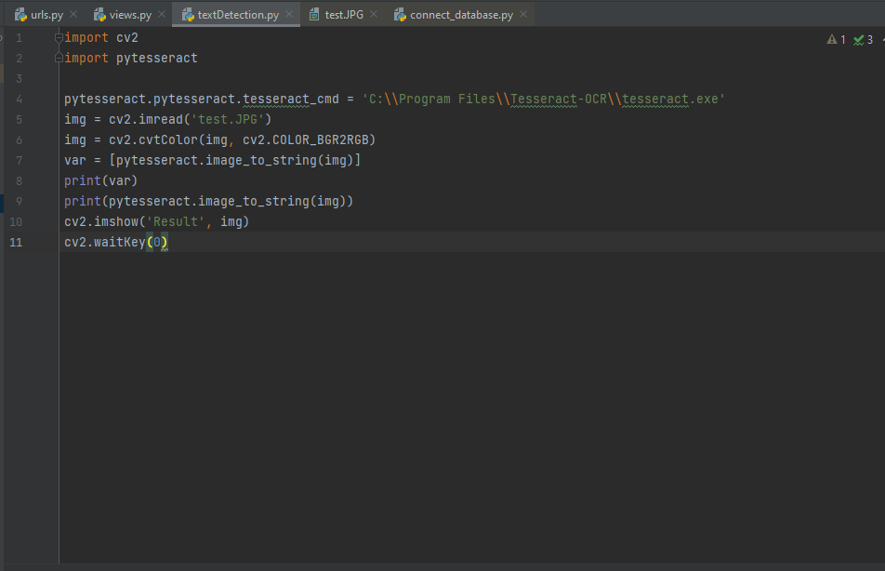

# Appendix B

Mass Messaging

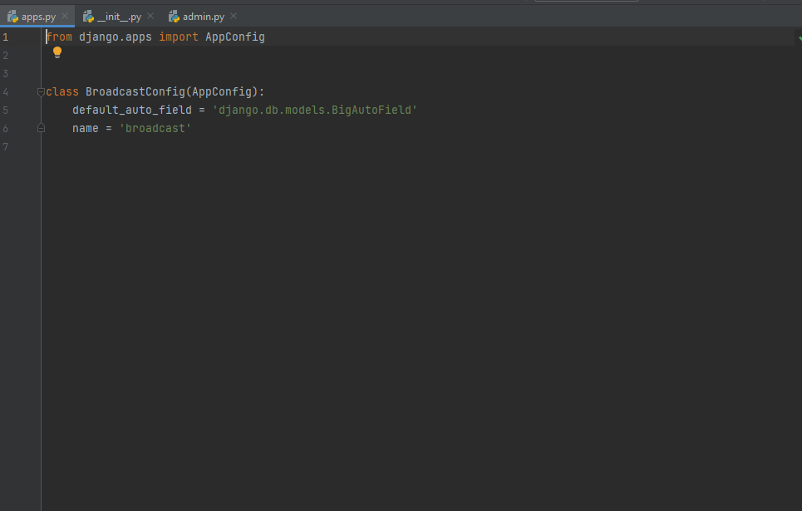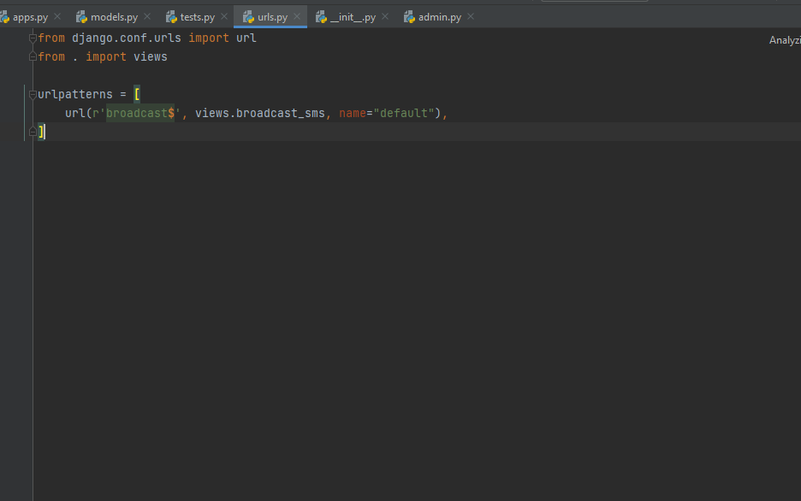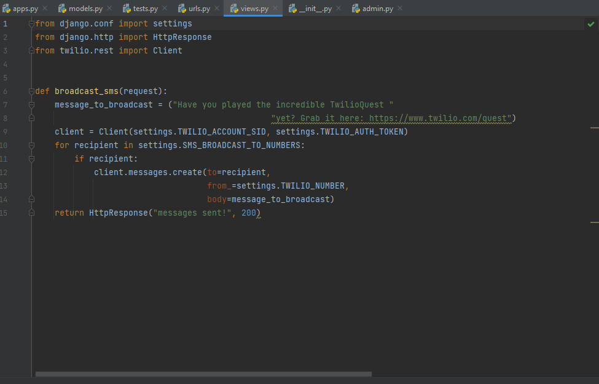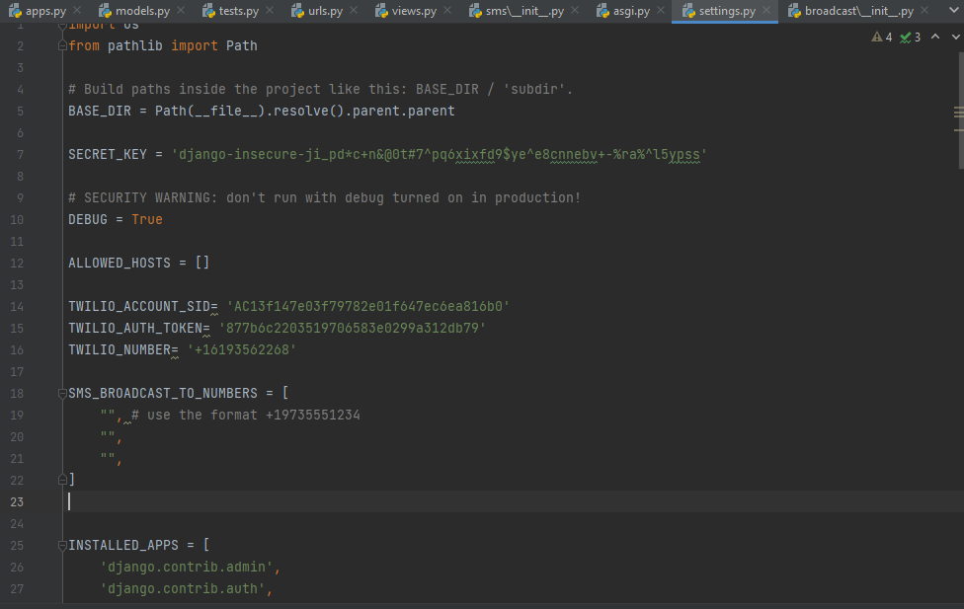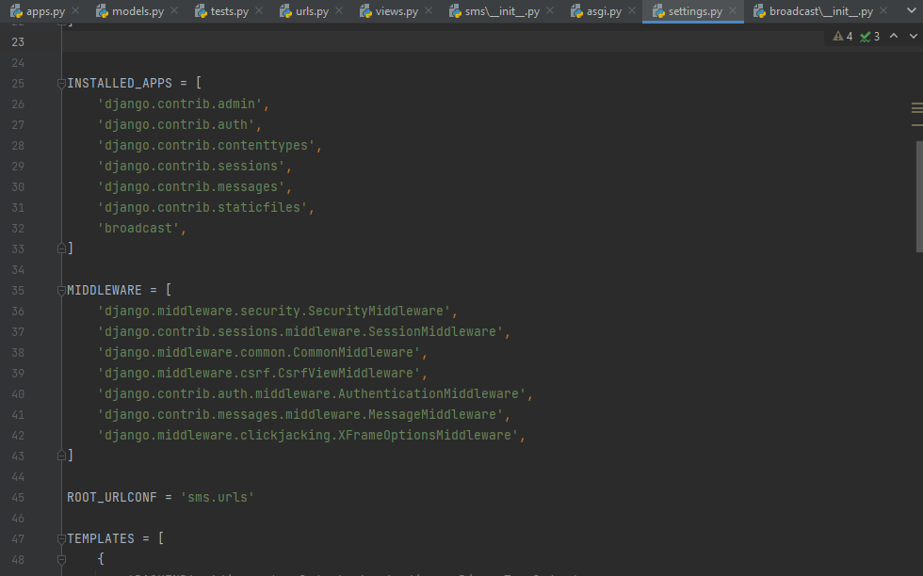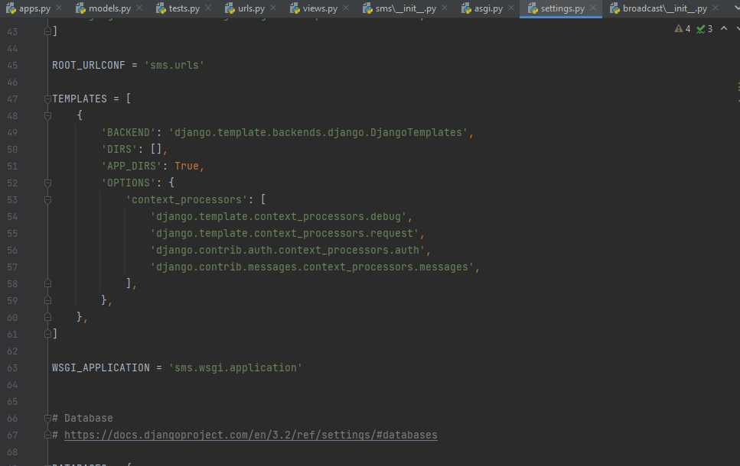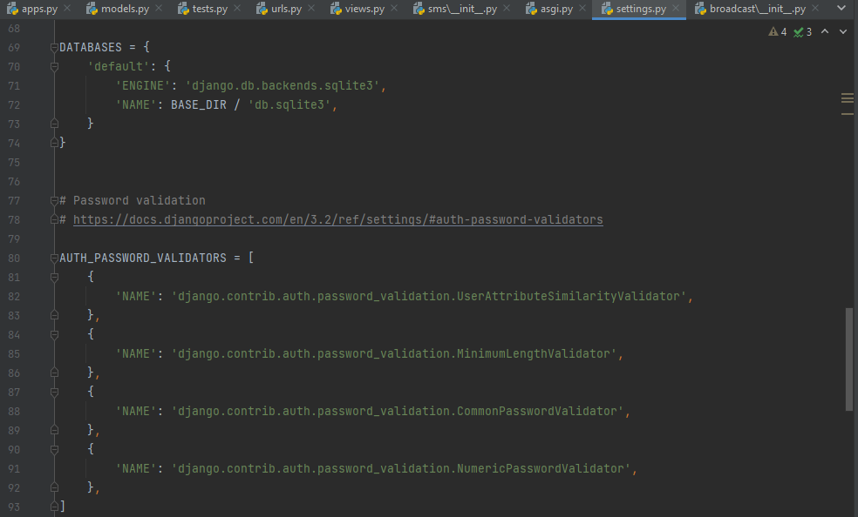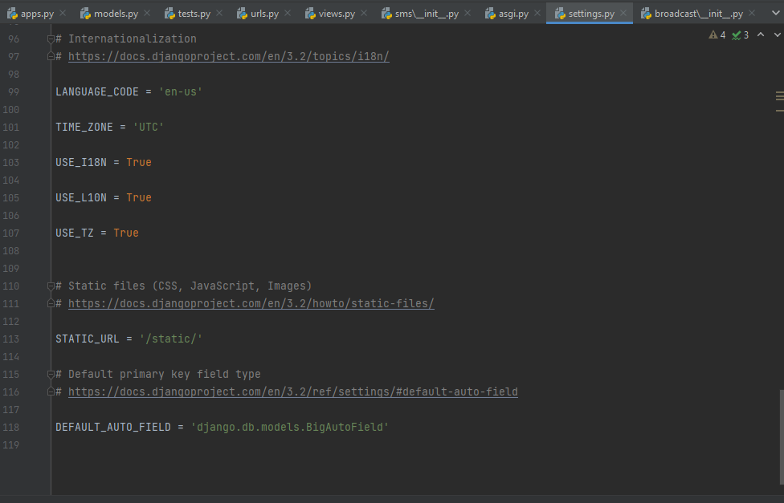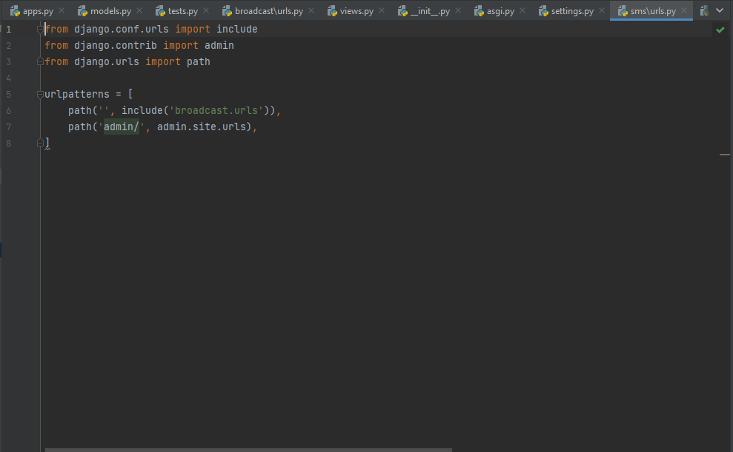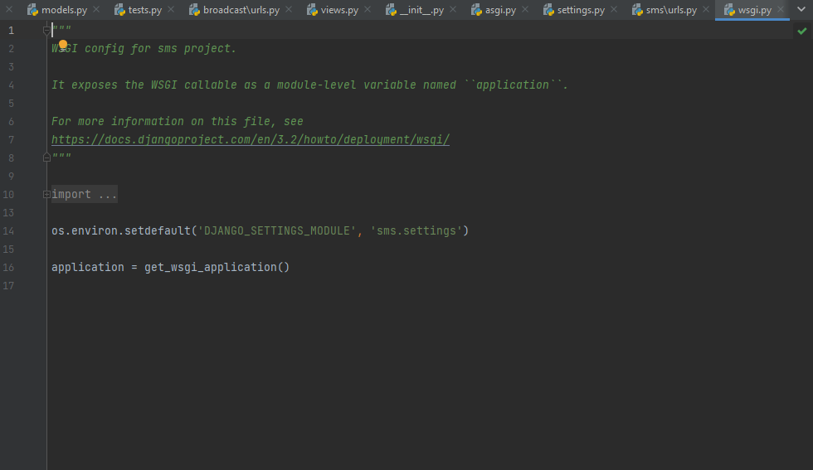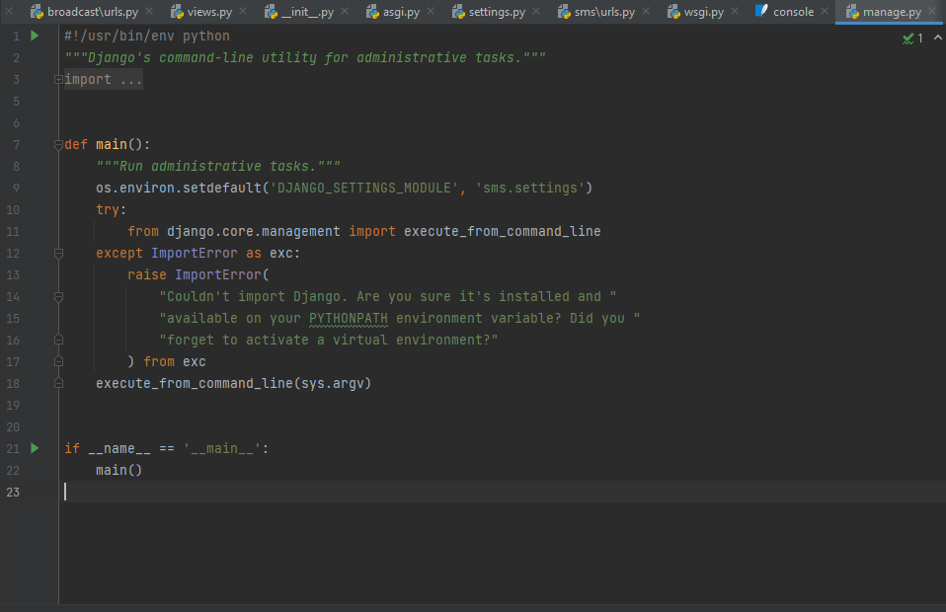

# Appendix C

Database

